Report for ForestQuery into Global Deforestation, 1990 to 2016

ForestQuery is on a mission to combat deforestation around the world and to raise awareness about this topic and its impact on the environment. The data analysis team at ForestQuery has obtained data from the World Bank that includes forest area and total land area by country and year from 1990 to 2016, as well as a table of countries and the regions to which they belong.

The data analysis team has used SQL to bring these tables together and to query them in an effort to find areas of concern as well as areas that present an opportunity to learn from successes.

## 1. **GLOBAL SITUATION**

According to the World Bank, the total forest area of the world was 41.282.694.9_sq.km_________________ in 1990. As of 2016, the most recent year for which data was available, that number had fallen to___39.958.245.9_sq.km______________, a loss of _13.244.490_sq.km________________, or ______3.21____________%.

The forest area lost over this time period is slightly more than the entire land area of __

_Peru___listed for the year 2016 (which is _1279999.9891 sq.km_____).

## 2. **REGIONAL OUTLOOK**

In 2016, the percent of the total land area of the world designated as forest was ______________31.38%____. The region with the highest relative forestation was__

___Latin America & Caribbean___________, with ____46.16%______________%, and the region with the lowest relative forestation was __Middle East & North Africa________________, with _________2.07%_________% forestation.

In 1990, the percent of the total land area of the world designated as forest was __________32.42%________. The region with the highest relative forestation was___

_Latin America & Caribbean______________, with ________51.03%__________%, and the region with the lowest relative forestation was __Middle East & North Africa________________, with _________1.78%_________% forestation.

Table 2.1: Percent Forest Area by Region, 1990 & 2016:

|  |  |  |
| --- | --- | --- |
| Region | 1990 Forest Percentage | 2016 Forest Percentage |
| Latin America & Caribbean | 51.03% | 46.16% |
| Sub-Saharan Africa | 30.67% | 28.79% |
| World | 32.42% | 31.38% |

The only regions of the world that decreased in percent forest area from 1990 to 2016 were _______________ Latin America & Caribbean ___ (dropped from _____51.03%_____________% to ________46.16%__________%) and ________

Sub-Saharan Africa __________ (__________30.67%________% to ___________28.79%_______%). All other regions actually increased in forest area over this time period. However, the drop in forest area in the two aforementioned regions was so large, the percent forest area of the world decreased over this time period from _________32.42%_________% to _________31.38%_________%.

## 3. **COUNTRY-LEVEL DETAIL**

### SUCCESS STORIES

There is one particularly bright spot in the data at the country level, _____China_____________. This country actually increased in forest area from 1990 to 2016 by ______527229.062 km²____________. It would be interesting to study what has changed in this country over this time to drive this figure in the data higher. The country with the next largest increase in forest area from 1990 to 2016 was the United States__________________, but it only saw an increase of _____79200 km²_____________, much lower than the figure for ______China____________.

United States__________________ and _______China___________ are of course very large countries in total land area, so when we look at the largest *percent* change in forest area from 1990 to 2016, we aren’t surprised to find a much smaller country listed at the top. _Iceland_________________ increased in forest area by ______213.66%____________% from 1990 to 2016.

### LARGEST CONCERNS

Which countries are seeing deforestation to the largest degree? We can answer this question in two ways. First, we can look at the absolute square kilometer decrease in forest area from 1990 to 2016. The following 3 countries had the largest decrease in forest area over the time period under consideration:

Table 3.1: Top 5 Amount Decrease in Forest Area by Country, 1990 & 2016:

|  |  |  |
| --- | --- | --- |
| Country | Region | Absolute Forest Area Change |
| Brazil | Latin America & Caribbean | 541,510 km² |
| Indonesia | East Asia & Pacific | 282.194 km² |
| Myanmar | East Asia & Pacific | 107.234 km² |
| Nigeria | Sub-Saharan Africa | 106.506 km² |
| Tanzania | Sub-Saharan Africa | 102.320 km² |

The second way to consider which countries are of concern is to analyze the data by percent decrease.

Table 3.2: Top 5 Percent Decrease in Forest Area by Country, 1990 & 2016:

|  |  |  |
| --- | --- | --- |
| Country | Region | Pct Forest Area Change |
| Togo | Sub-Saharan Africa | 75.45% |
| Nigeria | Sub-Saharan Africa | 61.80% |
| Uganda | Sub-Saharan Africa | 59.13% |
| Mauritania | Sub-Saharan Africa | 46.75% |
| Honduras | Latin America & Caribbean | 45.03% |

When we consider countries that decreased in forest area percentage the most between 1990 and 2016, we find that four of the top 5 countries on the list are in the region of __________ Sub-Saharan Africa ________. The countries are __ Togo,_ Nigeria ,__ Uganda ,_______ and ___ Mauritania _______________. The 5th country on the list is _________ Honduras _________, which is in the ________ Latin America & Caribbean __________ region.

From the above analysis, we see that ___________ Nigeria _______ is the only country that ranks in the top 5 both in terms of absolute square kilometer decrease in forest as well as percent decrease in forest area from 1990 to 2016. Therefore, this country has a significant opportunity ahead to stop the decline and hopefully spearhead remedial efforts.

### QUARTILES

Table 3.3: Count of Countries Grouped by Forestation Percent Quartiles, 2016:

|  |  |
| --- | --- |
| Quartile | Number of Countries |
| 0-25% | 85 |
| 25-50% | 73 |
| 50-75% | 38 |
| 75-100% | 22 |

The largest number of countries in 2016 were found in the _________1_________ quartile.

There were _______9___________ countries in the top quartile in 2016. These are countries with a very high percentage of their land area designated as forest. The following is a list of countries and their respective forest land, denoted as a percentage.

Table 3.4: Top Quartile Countries, 2016:

|  |  |  |
| --- | --- | --- |
| Country | Region | Pct Designated as Forest |
| Suriname | Latin America & Caribbean | 98.25% |
| Micronesia, Fed. Sts | East Asia & Pacific | 91.85% |
| Gabon | Sub-Saharan Africa | 90.03% |
| Seychelles | Sub-Saharan Africa | 88.41% |
| Palau | East Asia & Pacific | 87.60% |
| American Samoa | East Asia & Pacific | 87.50% |
| Guyana | Latin America & Caribbean | 83.90% |
| Lao PDR | East Asia & Pacific | 82.10% |
| Solomon Islands | East Asia & Pacific | 77.86% |

## 4. RECOMMENDATIONS

*Write out a set of recommendations as an analyst on the ForestQuery team.*

* *What have you learned from the World Bank data?*

*Here's a clearer explanation of the sentence comparing the lost forest area to the land area of Peru:"The forest area lost from 1990 to 2016 is slightly more than the entire land area of Peru in 2016, which is 1,279,999.9891 square kilometers."* *From 1990 to 2016, global forest coverage decreased from 32.42% to 31.38%, with Latin America & the Caribbean maintaining the highest forest coverage despite a reduction from 51.03% to 46.16%, while the Middle East & North Africa remained the region with the least forest area, though it slightly increased from 1.78% to 2.07%.* *The summary highlights significant changes in forest areas between 1990 and 2016, showcasing both absolute and relative increases in forest coverage across various countries. Here is a precise explanation of these developments:*

*China experienced the largest increase in forest area among all countries from 1990 to 2016, with a gain of 527,229.062 km². This remarkable growth far surpasses that of the United States, which had the second-largest increase but at a much smaller scale of 79,200 km². This data suggests significant environmental or policy shifts in China that could be valuable to analyze further. Despite their large total land areas, these increases are still notable. On the other hand, Iceland, a much smaller country, showed the most significant percent increase in forest area, with a 213.66% rise over the same period, underscoring how smaller nations can also achieve substantial proportional changes in forestation.*

*The report on forest area reductions from 1990 to 2016 highlights that Brazil experienced the largest absolute loss, with 541,510 km², followed by Indonesia, Myanmar, Nigeria, and Tanzania, which also saw significant decreases. Proportionally, Togo leads with a 75.45% decrease, underscoring its critical deforestation situation. Nigeria and Uganda also show substantial percentage losses. These trends underscore the need for targeted conservation measures and more sustainable land use practices, particularly in the most affected regions.*

* *Which countries should we focus on over others?*

To prioritize conservation efforts, focus should be given to countries with the most significant forest losses and those with ecologically valuable forests. Brazil and Indonesia are priorities due to their massive absolute declines, while Togo, Nigeria, and Uganda also require urgent attention due to their high percentage losses. Measures should aim at sustainable land use and strengthening local conservation laws to effectively support these countries in preserving and regenerating their forested areas.

## 5. APPENDIX: SQL Queries Used

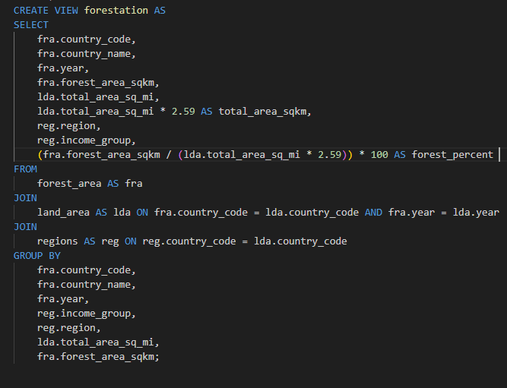

CREATE VIEW forestation AS

SELECT

fra.country_code,

fra.country_name,

fra.year,

fra.forest_area_sqkm,

lda.total_area_sq_mi,

lda.total_area_sq_mi * 2.59 AS total_area_sqkm,

reg.region,

reg.income_group,

(fra.forest_area_sqkm / (lda.total_area_sq_mi * 2.59)) * 100 AS forest_percent

FROM

forest_area AS fra

JOIN

land_area AS lda ON fra.country_code = lda.country_code AND fra.year = lda.year

JOIN

regions AS reg ON reg.country_code = lda.country_code

GROUP BY

fra.country_code,

fra.country_name,

fra.year,

reg.income_group,

reg.region,

lda.total_area_sq_mi,

fra.forest_area_sqkm;

**Part 1 - Global Situationa.**

What was the total forest area (in sq km) of the world in 1990? Please keep in mind that you can use the country record denoted as “World" in the region table.

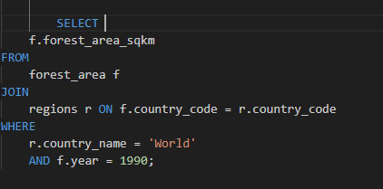

SELECT

f.forest_area_sqkm

FROM

forest_area f

JOIN

regions r ON f.country_code = r.country_code

WHERE

r.country_name = 'World'

AND f.year = 1990;

b. What was the total forest area (in sq km) of the world in 2016? Please keep in mind that you can use the country record in the table is denoted as “World.

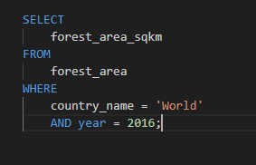

SELECT

forest_area_sqkm

FROM

forest_area

WHERE

country_name = 'World'

AND year = 2016;

c. What was the change (in sq km) in the forest area of the world from 1990 to 2016

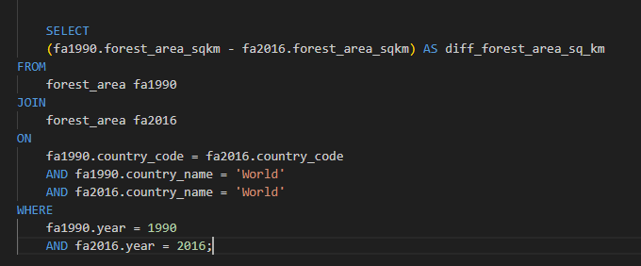

SELECT

(fa1990.forest_area_sqkm - fa2016.forest_area_sqkm) AS diff_forest_area_sq_km

FROM

forest_area fa1990

JOIN

forest_area fa2016

ON

fa1990.country_code = fa2016.country_code

AND fa1990.country_name = 'World'

AND fa2016.country_name = 'World'

WHERE

fa1990.year = 1990

AND fa2016.year = 2016;

d. What was the percent change in forest area of the world between 1990 and 2016?

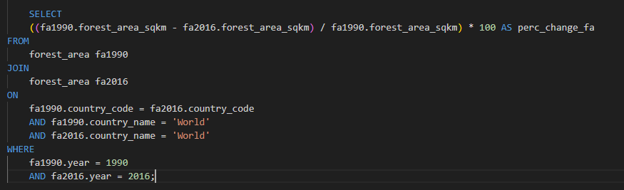

SELECT

((fa1990.forest_area_sqkm - fa2016.forest_area_sqkm) / fa1990.forest_area_sqkm) * 100 AS perc_change_fa

FROM

forest_area fa1990

JOIN

forest_area fa2016

ON

fa1990.country_code = fa2016.country_code

AND fa1990.country_name = 'World'

AND fa2016.country_name = 'World'

WHERE

fa1990.year = 1990

AND fa2016.year = 2016;

e. If you compare the amount of forest area lost between 1990 and 2016, to which country's total area in 2016 is it closest to?

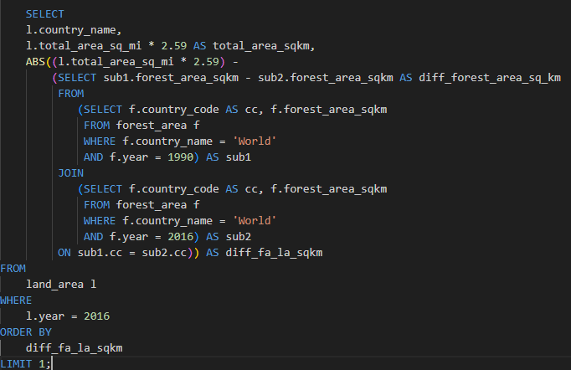

SELECT

l.country_name,

l.total_area_sq_mi * 2.59 AS total_area_sqkm,

ABS((l.total_area_sq_mi * 2.59) -

(SELECT sub1.forest_area_sqkm - sub2.forest_area_sqkm AS diff_forest_area_sq_km

FROM

(SELECT f.country_code AS cc, f.forest_area_sqkm

FROM forest_area f

WHERE f.country_name = 'World'

AND f.year = 1990) AS sub1

JOIN

(SELECT f.country_code AS cc, f.forest_area_sqkm

FROM forest_area f

WHERE f.country_name = 'World'

AND f.year = 2016) AS sub2

ON sub1.cc = sub2.cc)) AS diff_fa_la_sqkm

FROM

land_area l

WHERE

l.year = 2016

ORDER BY

diff_fa_la_sqkm

LIMIT 1;

**Part 2 - Regional Outlook**

Create a table that shows the Regions and their percent forest area (sum of forest area divided by the sum of land area) in 1990 and 2016. (Note that 1 sq mi = 2.59 sq km)

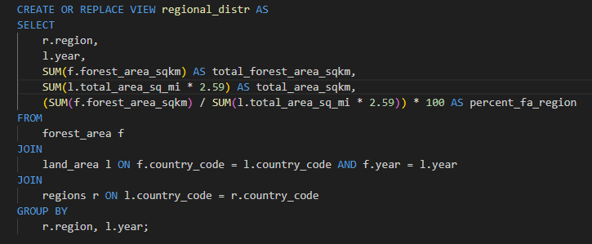

CREATE OR REPLACE VIEW regional_distr AS

SELECT

r.region,

l.year,

SUM(f.forest_area_sqkm) AS total_forest_area_sqkm,

SUM(l.total_area_sq_mi * 2.59) AS total_area_sqkm,

(SUM(f.forest_area_sqkm) / SUM(l.total_area_sq_mi * 2.59)) * 100 AS percent_fa_region

FROM

forest_area f

JOIN

land_area l ON f.country_code = l.country_code AND f.year = l.year

JOIN

regions r ON l.country_code = r.country_code

GROUP BY

r.region, l.year;

What was the percent forest of the entire world in 2016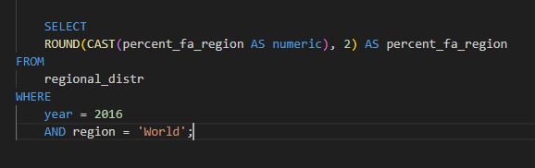

SELECT

ROUND(CAST(percent_fa_region AS numeric), 2) AS percent_fa_region

FROM

regional_distr

WHERE

year = 2016

AND region = 'World';

Which region had the HIGHEST percent forest in 2016, and which had the LOWEST, to 2 decimal places?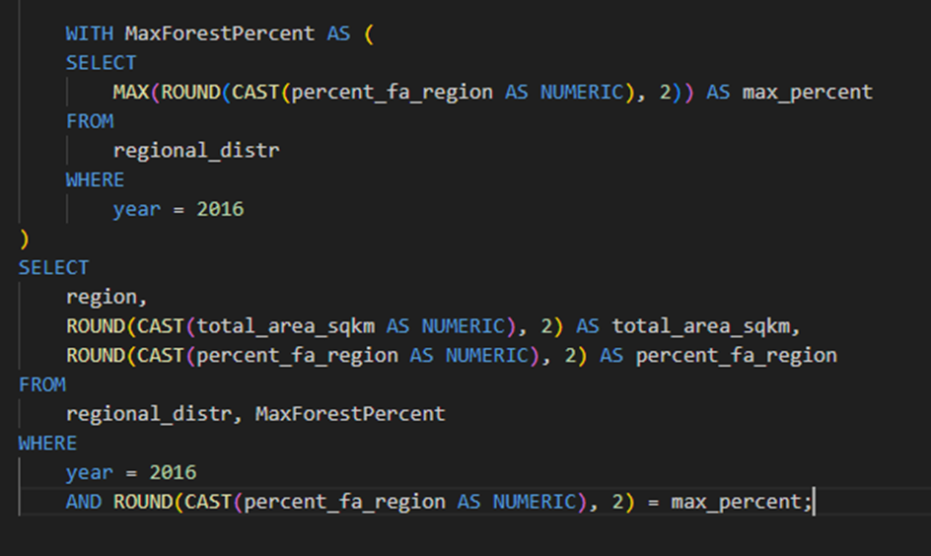

WITH MaxForestPercent AS (

SELECT

MAX(ROUND(CAST(percent_fa_region AS NUMERIC), 2)) AS max_percent

FROM

regional_distr

WHERE

year = 2016

)

SELECT

region,

ROUND(CAST(total_area_sqkm AS NUMERIC), 2) AS total_area_sqkm,

ROUND(CAST(percent_fa_region AS NUMERIC), 2) AS percent_fa_region

FROM

regional_distr, MaxForestPercent

WHERE

year = 2016

AND ROUND(CAST(percent_fa_region AS NUMERIC), 2) = max_percent;

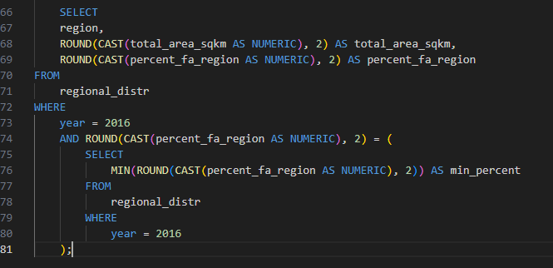

SELECT

region,

ROUND(CAST(total_area_sqkm AS NUMERIC), 2) AS total_area_sqkm,

ROUND(CAST(percent_fa_region AS NUMERIC), 2) AS percent_fa_region

FROM

regional_distr

WHERE

year = 2016

AND ROUND(CAST(percent_fa_region AS NUMERIC), 2) = (

SELECT

MIN(ROUND(CAST(percent_fa_region AS NUMERIC), 2)) AS min_percent

FROM

regional_distr

WHERE

year = 2016

);

What was the percent forest of the entire world in 1990.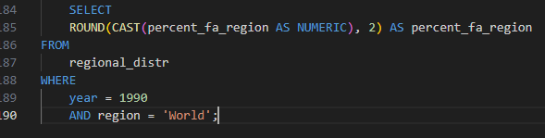

SELECT

ROUND(CAST(percent_fa_region AS NUMERIC), 2) AS percent_fa_region

FROM

regional_distr

WHERE

year = 1990

AND region = 'World';

Which region had the HIGHEST percent forest in 1990, and which had the LOWEST, to 2 decimal places?

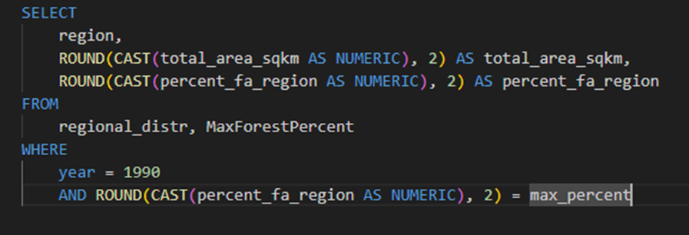

WITH MaxForestPercent AS (

SELECT

MAX(ROUND(CAST(percent_fa_region AS NUMERIC), 2)) AS max_percent

FROM

regional_distr

WHERE

year = 1990

)

SELECT

region,

ROUND(CAST(total_area_sqkm AS NUMERIC), 2) AS total_area_sqkm,

ROUND(CAST(percent_fa_region AS NUMERIC), 2) AS percent_fa_region

FROM

regional_distr, MaxForestPercent

WHERE

year = 1990

AND ROUND(CAST(percent_fa_region AS NUMERIC), 2) = max_percent

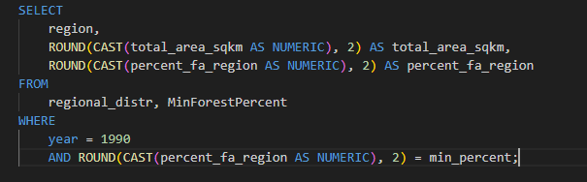

WITH MinForestPercent AS (

SELECT

MIN(ROUND(CAST(percent_fa_region AS NUMERIC), 2)) AS min_percent

FROM

regional_distr

WHERE

year = 1990

)

SELECT

region,

ROUND(CAST(total_area_sqkm AS NUMERIC), 2) AS total_area_sqkm,

ROUND(CAST(percent_fa_region AS NUMERIC), 2) AS percent_fa_region

FROM

regional_distr, MinForestPercent

WHERE

year = 1990

AND ROUND(CAST(percent_fa_region AS NUMERIC), 2) = min_percent

c. Based on the table you created, which regions of the world DECREASED in forest area from 1990 to 2016?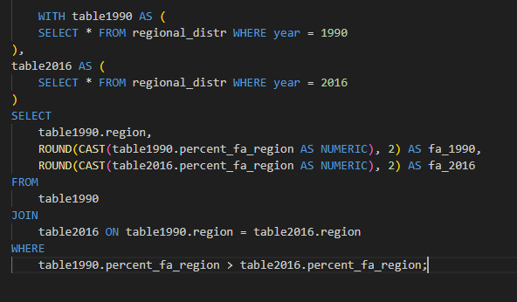

WITH table1990 AS (

SELECT * FROM regional_distr WHERE year = 1990

),

table2016 AS (

SELECT * FROM regional_distr WHERE year = 2016

)

SELECT

table1990.region,

ROUND(CAST(table1990.percent_fa_region AS NUMERIC), 2) AS fa_1990,

ROUND(CAST(table2016.percent_fa_region AS NUMERIC), 2) AS fa_2016

FROM

table1990

JOIN

table2016 ON table1990.region = table2016.region

WHERE

table1990.percent_fa_region > table2016.percent_fa_region;

**Part 3 - Country-Level Detail**

a.

Which 5 countries saw the largest amount decrease in forest area from 1990 to 2016?

What was the difference in forest area for each?

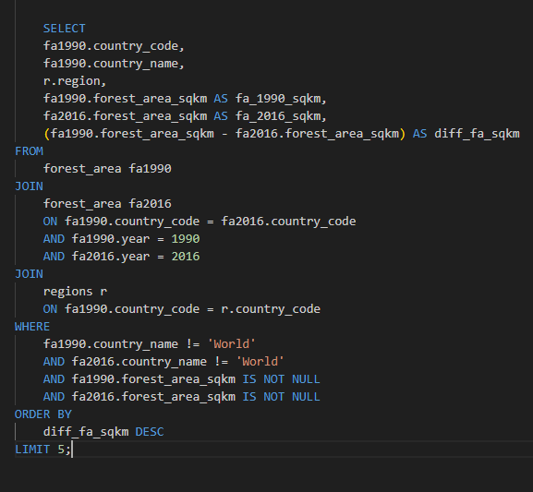

SELECT

fa1990.country_code,

fa1990.country_name,

r.region,

fa1990.forest_area_sqkm AS fa_1990_sqkm,

fa2016.forest_area_sqkm AS fa_2016_sqkm,

(fa1990.forest_area_sqkm - fa2016.forest_area_sqkm) AS diff_fa_sqkm

FROM

forest_area fa1990

JOIN

forest_area fa2016

ON fa1990.country_code = fa2016.country_code

AND fa1990.year = 1990

AND fa2016.year = 2016

JOIN

regions r

ON fa1990.country_code = r.country_code

WHERE

fa1990.country_name != 'World'

AND fa2016.country_name != 'World'

AND fa1990.forest_area_sqkm IS NOT NULL

AND fa2016.forest_area_sqkm IS NOT NULL

ORDER BY

diff_fa_sqkm DESC

LIMIT 5;

b. Which 5 countries saw the largest percent decrease in forest area from 1990 to 2016?What was the percent change to 2 decimal places for each?

SELECT

f1990.country_name,

f1990.region,

ROUND(SUM(f1990.forest_area_sqkm)::NUMERIC, 2) AS Forest_Area_sqkm_1990,

ROUND(SUM(f2016.forest_area_sqkm)::NUMERIC, 2) AS Forest_Area_sqkm_2016,

ROUND((SUM(f1990.forest_area_sqkm) - SUM(f2016.forest_area_sqkm))::NUMERIC, 2) AS Difference_Land_Area,

ROUND((CASE

WHEN SUM(f1990.forest_area_sqkm) > 0 THEN

(SUM(f1990.forest_area_sqkm) - SUM(f2016.forest_area_sqkm)) / SUM(f1990.forest_area_sqkm) * 100

ELSE 0

END)::NUMERIC, 2) AS Difference_Percentage_Land_Area

FROM

forestation f1990

JOIN

forestation f2016

ON f1990.country_name = f2016.country_name AND f1990.region = f2016.region AND f1990.year = 1990 AND f2016.year = 2016

WHERE

f1990.country_name != 'World' AND

f1990.forest_area_sqkm IS NOT NULL AND

f2016.forest_area_sqkm IS NOT NULL

GROUP BY

f1990.country_name, f1990.region

ORDER BY

Difference_Percentage_Land_Area DESC

LIMIT 5;

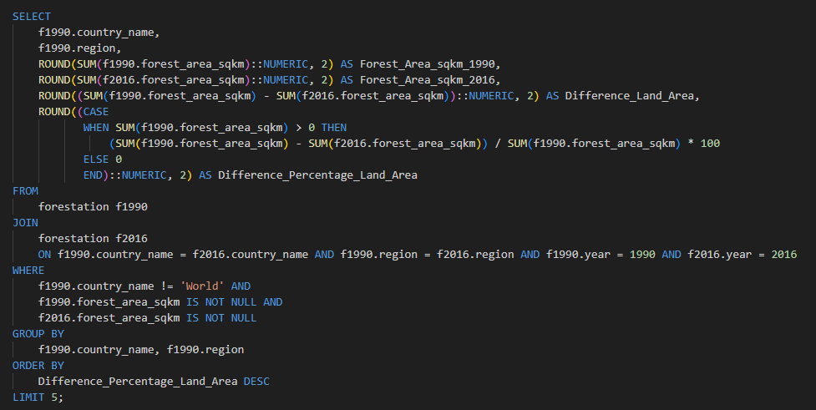

.

. If countries were grouped by percent forestation in quartiles, which group had the most countries in it in 2016?

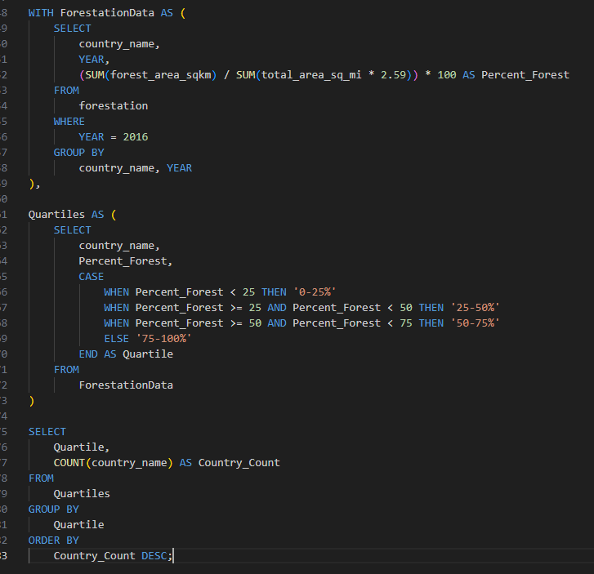

WITH ForestationData AS (

SELECT

country_name,

YEAR,

(SUM(forest_area_sqkm) / SUM(total_area_sq_mi * 2.59)) * 100 AS Percent_Forest

FROM

forestation

WHERE

YEAR = 2016

GROUP BY

country_name, YEAR

),

Quartiles AS (

SELECT

country_name,

Percent_Forest,

CASE

WHEN Percent_Forest < 25 THEN '0-25%'

WHEN Percent_Forest >= 25 AND Percent_Forest < 50 THEN '25-50%'

WHEN Percent_Forest >= 50 AND Percent_Forest < 75 THEN '50-75%'

ELSE '75-100%'

END AS Quartile

FROM

ForestationData

)

SELECT

Quartile,

COUNT(country_name) AS Country_Count

FROM

Quartiles

GROUP BY

Quartile

ORDER BY

Country_Count DESC;

d. List all of the countries that were in the 4th quartile (percent forest > 75%) in 2016.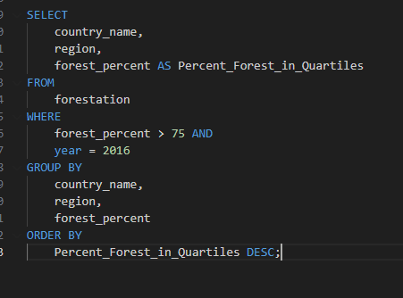

SELECT

country_name,

region,

forest_percent AS Percent_Forest_in_Quartiles

FROM

forestation

WHERE

forest_percent > 75 AND

year = 2016

GROUP BY

country_name,

region,

forest_percent

ORDER BY

Percent_Forest_in_Quartiles DESC;

e. How many countries had a percent forestation higher than the United States in 2016?

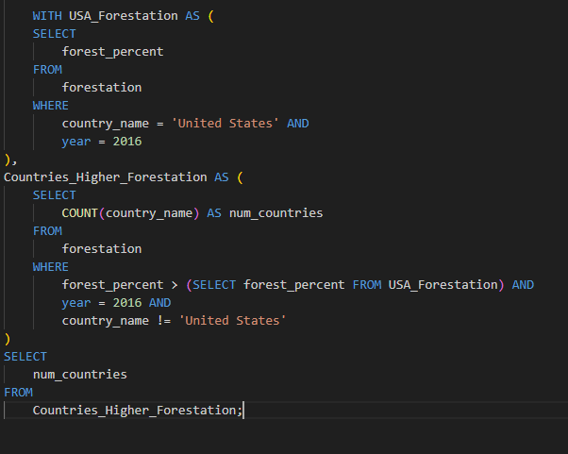

WITH USA_Forestation AS (

SELECT

forest_percent

FROM

forestation

WHERE

country_name = 'United States' AND

year = 2016

),

Countries_Higher_Forestation AS (

SELECT

COUNT(country_name) AS num_countries

FROM

forestation

WHERE

forest_percent > (SELECT forest_percent FROM USA_Forestation) AND

year = 2016 AND

country_name != 'United States'

)

SELECT

num_countries

FROM

Countries_Higher_Forestation;